Experiment 2 (a)

Aim:To model a 50 Ω microwave two-port transmission-line network of length 50 mm, operate it over 8–12 GHz with a center frequency of 10 GHz, and obtain the scattering parameters S₁₁, S₁₂, S₂₁ and S₂₂. At 10 GHz, calculate the return loss (RL), insertion loss (IL), and transmission efficiency, and compare the simulated results with an ideal 50 Ω matched reference.

Procedure:
- Open HFSS and create a new 3D electromagnetic design.
- Set the model units to mm.
- Construct a microwave transmission-line/two-port structure having:
- Length = 50 mm
- Characteristic impedance = 50 Ω.
- Assign the appropriate conductor and dielectric properties to the transmission line.
- Define Port 1 at one end and Port 2 at the other end.
- Set both ports to a 50 Ω reference impedance.
- Set the solution/analysis frequency to 10 GHz.
- Define a frequency sweep from 8 GHz to 12 GHz.
- Run the HFSS simulation.
- From the simulation results, plot:
- S11S_{11} — input reflection coefficient
- S21S_{21} — forward transmission coefficient
- S12S_{12} — reverse transmission coefficient
- S22S_{22} — output reflection coefficient.
- Read the S-parameter values at 10 GHz.
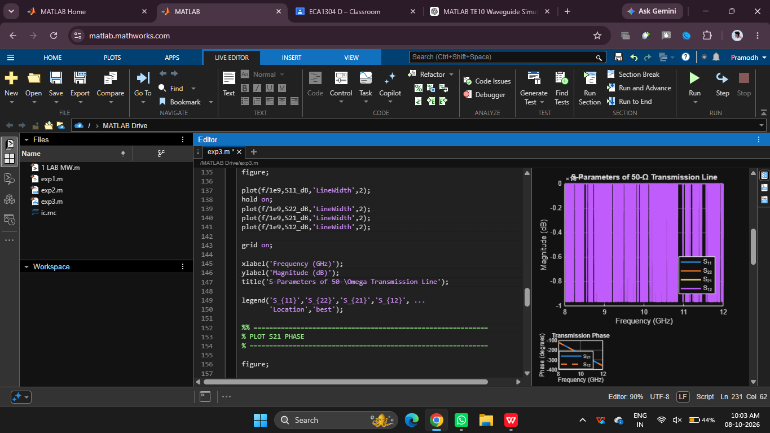

Result:
The 50 Ω microwave two-port transmission-line network of length 50 mm was successfully modeled and analyzed from 8 to 12 GHz, with 10 GHz as the center frequency.

The S-parameters \(S_{11},S_{12},S_{21}\), and \(S_{22}\) were obtained from HFSS. At 10 GHz, a properly matched transmission line should exhibit very low \(S_{11}\) and \(S_{22}\) and \(S_{21}\) and \(S_{12}\) close to unity.

(b)
Aim:
To identify the optimum operating frequency from the 8–12 GHz S-parameter sweep at which ∣S11∣|S_{11}|∣S11​∣ is minimum and ∣S21∣|S_{21}|∣S21​∣ is maximum, calculate the return loss and insertion loss at that frequency, and compare the results with those at 10 GHz.

Procedure:

- Open the previously designed 50 Ω microwave two-port transmission-line model in ANSYS HFSS.

- Set the frequency sweep from 8 GHz to 12 GHz, with 10 GHz as the center frequency.

- Assign 50 Ω reference impedance to both input and output ports.

- Run the simulation and obtain the S-parameter plots.

- Plot S11S_{11}S11​ and S21S_{21}S21​ in dB over the complete frequency range.

- Identify the frequency at which S11S_{11}S11​ reaches its minimum magnitude (most negative value in dB).

- Identify the frequency at which S21S_{21}S21​ reaches its maximum magnitude (closest to 0 dB for a passive network).

- Use the HFSS marker function to record the exact frequency and corresponding S11S_{11}S11​ and S21S_{21}S21​ values.

- Calculate return loss and insertion loss using:

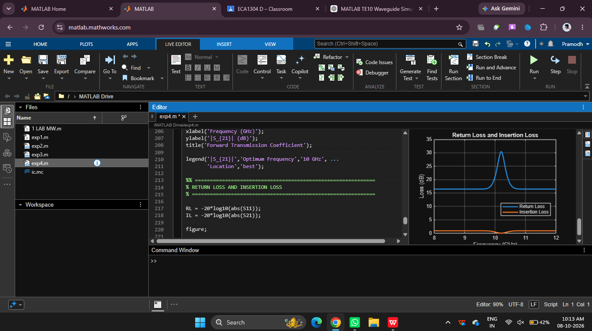

Result:
The optimum operating frequency is identified from the HFSS S-parameter sweep as the frequency where ∣S11∣|S_{11}|∣S11​∣ is minimum and ∣S21∣|S_{21}|∣S21​∣ is maximum. The exact frequency must be obtained from the actual simulation markers; it cannot be determined from the frequency range alone.

